**Introduction**

Martinrea is a global manufacturer of automotive parts located in Ontario, Canada. This firm is known for its high-quality automotive components and has numerous distributors in various countries. Historically named the Royal Laser Tech Corporation, the firm changed its name to Marthinera after buying Rea International. The firm became General Motors' number one product and part supplier and eventually declared that it would produce various critical elements and components for passenger cars (Martinrea, 2021). Martinrea is proud to provide highly-endorsed infrastructure services, which are part and parcel of its product and service offerings through its business group approach. Every organization employs a cooperative, successful approach as the foundation of its performance, through the paper to the floor. Martinrea collaborates effectively with stakeholders and other sectors, focusing on the constantly evolving automotive industry, to produce innovative products and solutions. Their clients encompass car manufacturers, industry, agriculture as well as aviation.

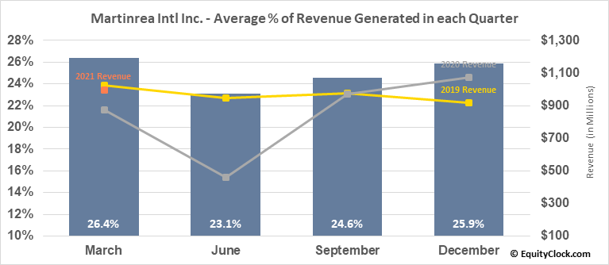

**Figure 1: Marthinera company**

Source: (Martinrea, 2021)

**Analysis**

**The supply chain**

Certainly, the supply chain (SC) is becoming a crucial aspect because of global progress, fast technology innovation, and increased regional impact (Al-Doori, 2019). Concurrence has now moved from organizations to industries; any disturbance can disturb not just the organization but the entire sector as well.

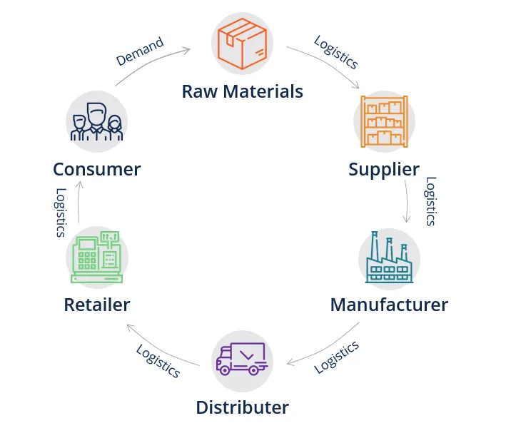

**Figure: Supply chain**

Source: (Al-Doori, 2019)

**Procurement of production parts**

In essence, the automobile industry's supply chain is comparable to other sectors. Numerous manufacturing processes, including the acquisition of replacement components, engine assembly, projection design, and display design, are taken consecutively (Mathivathanan, Kannan, & Haq, 2018). The issue is to keep the replacement components utilized to constantly meet those standards and divisions of operation or product development. One should always have the required components. Otherwise, the sequence of tasks already performed may vary. Automotive products offer millions of people mobility, create employment and endanger the ecosystem.

**Operator and equipment management**

Employees or technicians must know exactly what equipment and components must be installed in each engine unit in each assemblage portion. The production department clearly prepared all essential information and compulsory installation requirements (Jajja, Chatha & Farooq, 2018). Not just anyone, but the employees also have to understand all the equipment used to install replacement components, to discover the right torque configuration for each existing screw. The literature on the supply chain emphasizes the significance for companies confronting the supply chain risk of performing flexibility.

**Availability of Production Parts**

The availability of replacement components is an essential factor in Marthinera's supply chain. Customer satisfaction elements also require efficient procurement services. Changes in-vehicle components and parts should always be prepared in different ways. This is because of each motor vehicle owner's model and set up selections (Handfield, Graham & Burns, 2020). Auto owners must also have access to key parts for a long time.  A variety of reasons are available to standardize and integrate the production of spare parts according to the logistics process in the whole supply chain, including estimates and planning of the need for replacement parts, the connectivity between all partners and parts systems, warehouse management of goods entering goods, and until the inventory of spare parts is complete (Katiyar et al., 2018). In recent 3 decades, developments have posed a further challenge to the modeling of the entire supply chain.

**Storage and assembly warehouse**

Nowadays, numerous companies regard adopting sustainability methods not just as a competitive advantage, but also as a need for long-term survival. Consequently, durability is important to measure the performance of the supply chain. The emerging economies index shows that 10 percent of the overall market capitalization is represented in the emerging economies (Attaran, 2017). In addition to supplying their market, the developing economies serve as a worldwide production basis. Manufacturers must transition to low-frequency manufacturing of creative and tailor-made products of high added value to compete in a worldwide economy. Furthermore, the management and assembly of the supply chain are no less crucial. The two are typically divided by Marthinera. Certainly, all current warehouses are required to fulfill domestic and international storage requirements to ensure a seamless operation across the supply chain. This is strongly linked to the entire management of the cycle chain from the supply of raw materials to the distribution of products to the customers.

**Organizational structure**

A system that explains how specific actions are carried out to attain Marthinera's objectives is a structure of the organization. These activities may involve regulations, positions, and duties. The organizational structure influences well how devices communicate across corporate levels. In a universal database, for illustration, choices flow from above, whereas decision-making authority is spread at several levels in a decentralized structure (Dedahanov, Rhee & Yoon, 2017). Organizational development is a key component helping businesses to thrive in a changing environment, and it is considered to be one way to succeed and compete since it enables Marthinera to stay ahead of its competitors, inspire customers and generate future product catalogs.

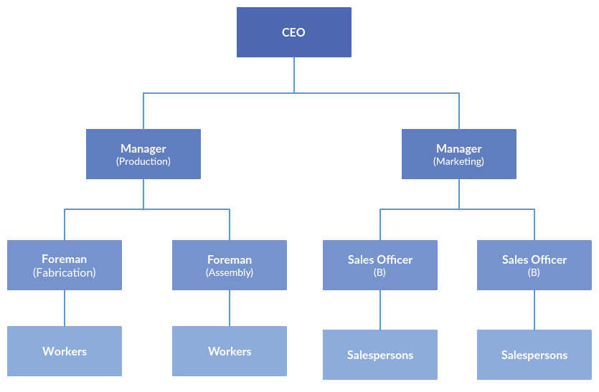

**Figure 3: Organizational structure**

Source: (Dedahanov, Rhee & Yoon, 2017)

**Poor communication**

A poor organization, since employees may not know who needs information or where to deliver essential communications, can lead to misunderstanding. For example, in order to enable new customers to start buying, a sales manager in Marthinera may design a new customer registration form, which would be approved by the owner. If the updated document is not shared with the bookkeeper, she may not be able to correctly qualify or charge new clients for the credit (Moşteanu, 2020). This might cause delayed deliveries and extended waiting periods for customers to pay. This can also lead to customers not being forced to locate a new provider. Successful corporate transformation needs the application of all the components, attention, and passion and does not take shorts.

**Lack of strategic management**

The reality that organizational decision-making is typically dependent on each other at all stages and has an influence that ranges from immediate to long-term can be regarded as a difficult process (Huggins, 2019). Considering quantitative decision-making and procedural frameworks, decision-making is essentially defined by several decisions from the problem to the decision. To optimize the potential for expansion, Marthinrea has to prepare for the future, instead of just waiting for new companies. It would be impossible to develop successful long-term strategies without an organizational structure that brings together important managers and staff on a regular basis. These initiatives frequently need marketing, financial, IT, manufacture, and sale management to provide input (Moradi et al., 2021). In today's competitive environment, business model design becomes an indispensable source of corporate innovation.

**Reduced productivity**

Martinrea can overlook chances, allow issues to linger, and lower employee morale if the business hasn't been creating effective communications or does not promote innovative strategic management. An individual who seems to have two supervisors might get conflicting orders and will not obey them unless they have received consent from above. They just wouldn't give fresh ideas or quit for a better position if employees are not satisfied. Management is considered a human activity, dealing with products and services manufacture and distribution.

**Damaged company**

Besides Marthinera's exterior dissatisfaction, they might suffer a bad organizational structure and generate issues for their clients. In such cases, they could lose clients, lose information and the capacity to recruit new consumers, and cut earnings sufficiently to hurt the firm.

**Implementation of channel coordination in the supply chain management of Martinrea**

Channel coordination is a supply chain management theory used when required to move large quantities of objects. The management requires large interference from logistics companies. Logistics companies decide when and how to move different goods so that orders are fulfilled at the right time (Kumar, Jakhar and Bhattacharya, 2021). They can align the transportation so that other levels of the supply chain continue to function efficiently.

The company ought to be able to provide automotive parts to the manufacturing units of the local automobile companies and automobile service stations. Both of these require huge quantities of goods to be transported. As a result, chain coordination will work best for it. The spare parts can be handed over to the logistics company. They will transport it along with other goods. This mass transportation will save both time and cost for Martinrea (Pan et al., 2021). Also, the orders of multiple companies can be fulfilled, bringing in more profits to the logistics company as well. Also, logistics can mediate as the link between manufacturers and retailers (car showrooms in this case). This will create an accountable environment between the company, the manufacturers and the suppliers. This will aid in improving the quality of service to a great extent.



Figure 4: Channel Coordination Flow Chart

Source: (Kumar, Jakhar and Bhattacharya, 2021)

**Conclusion 100**

This report provides an insight into the broad aspects of Martinrea’s supply chain management protocol. The company needs to push up its inventory to further enhance the supply rate. Goods need to be kept in proper and well-maintained warehouses to ensure quality. Technicians working in the firm are required to have accurate knowledge of how to handle different tools and equipment. A well-organized structure is important, prior to its flourishing. Also, the major strategy of the company is systematically the supply chain should be to adhere to chain coordination. The customers will eventually be satisfied with the company.

**Reference List**

Martinrea. (2021). *Home - Martinrea International*. Martinrea International. Retrieved from: [https://www.martinrea.com/](https://www.blogger.com/blog/post/edit/4668880262771047993/8835389979095562140).

Al-Doori, J. A. (2019). The impact of supply chain collaboration on performance in automotive industry: Empirical evidence. *Journal of Industrial Engineering and Management*, *12*(2), 241-253. Retrieved from: [https://upcommons.upc.edu/bitstream/handle/2117/175978/2835-11268-1-PB.pdf](https://www.blogger.com/blog/post/edit/4668880262771047993/8835389979095562140)

Mathivathanan, D., Kannan, D., & Haq, A. N. (2018). Sustainable supply chain management practices in Indian automotive industry: A multi-stakeholder view. *Resources, Conservation and Recycling*, *128*, 284-305. Retrieved from: [https://fardapaper.ir/mohavaha/uploads/2018/04/Fardapaper-Sustainable-supply-chain-management-practices-in-Indian-automotive-industry-A-multi-stakeholder-view.pdf](https://www.blogger.com/blog/post/edit/4668880262771047993/8835389979095562140)

Jajja, M. S. S., Chatha, K. A., & Farooq, S. (2018). Impact of supply chain risk on agility performance: Mediating role of supply chain integration. *International Journal of Production Economics*, *205*, 118-138. Retrieved from: [https://www.researchgate.net/profile/Muhammad-Shakeel-Sadiq-Jajja/publication/339127225_Supply_Chain_Risk_Management_and_Operational_Performance_The_Enabling_Role_of_Supply_Chain_Integration/links/5ec3ba41458515626cb50fbe/Supply-Chain-Risk-Management-and-Operational-Performance-The-Enabling-Role-of-Supply-Chain-Integration.pdf](https://www.blogger.com/blog/post/edit/4668880262771047993/8835389979095562140)

Handfield, R. B., Graham, G., & Burns, L. (2020). Corona virus, tariffs, trade wars and supply chain evolutionary design. *International Journal of Operations & Production Management*. Retrieved from: [https://eprints.whiterose.ac.uk/161923/1/PDF_Proof%20%282%29.PDF](https://www.blogger.com/blog/post/edit/4668880262771047993/8835389979095562140)

Katiyar, R., Meena, P. L., Barua, M. K., Tibrewala, R., & Kumar, G. (2018). Impact of sustainability and manufacturing practices on supply chain performance: Findings from an emerging economy. *International Journal of Production Economics*, *197*, 303-316. Retrieved from: [https://www.researchgate.net/profile/Purushottam-Meena/publication/321716482_Impact_of_Sustainability_and_Manufacturing_Practices_on_Supply_Chain_Performance_Findings_from_an_Emerging_Economy/links/5a31e4bca6fdcc9b2d9c6ac1/Impact-of-Sustainability-and-Manufacturing-Practices-on-Supply-Chain-Performance-Findings-from-an-Emerging-Economy.pdf](https://www.blogger.com/blog/post/edit/4668880262771047993/8835389979095562140)

Attaran, M. (2017). Additive manufacturing: the most promising technology to alter the supply chain and logistics. *Journal of Service Science and Management*, *10*(03), 189. Retrieved from: [https://www.scirp.org/html/1-9201960_75953.htm?pagespeed=noscript](https://www.blogger.com/blog/post/edit/4668880262771047993/8835389979095562140)

Dedahanov, A. T., Rhee, C., & Yoon, J. (2017). Organizational structure and innovation performance. *Career Development International*. Retrieved from: [https://d1wqtxts1xzle7.cloudfront.net/63663546/Organizational_Structure_and_Innovation_Performance__is_employee_innovative_behavior_a_missing_link20200617-4748-163hb2a-with-cover-page-v2.pdf?Expires=1629112090&Signature=ShA-swifLYqwa0kIIuBBSFahTQNzuzNMLnxzhhEsC7AGdr1~veSiSLctsv1U0yYQ2E4CtHKNJi07xkBlxmXOsWAdCCE1TdshLtqgf95jq-UX6BiATPYnp7m-QXAGyu4SriDDEzfnueMj9L1mb-7GgJBmBEIPCdTo2bgdcEgWiNazff5L0bs7SXSD7p~mX-ZATtcVwO2~9JqHu8ltLUTLKIm1-8D1HFFl8AfptkeTcPdQ4TkjldKZJ6GzkQQtCgF-Rwi~1~qcUxcaTnz7LwauV4dp0dNRP1ywl8wRG7~odMxbWikhKnVUZ09aQJG4N3Qh~HwlGa99SAdqoY7Ki3TxNw__&Key-Pair-Id=APKAJLOHF5GGSLRBV4ZA](https://www.blogger.com/blog/post/edit/4668880262771047993/8835389979095562140)

Moşteanu, N. R. (2020). Challenges for Organizational Structure and design as a result of digitalization and cybersecurity. *The Business & Management Review*, *11*(1), 278-286. Retrieved from: [https://www.researchgate.net/profile/Hany-Hanna-2/publication/344793035_TOE_Model_Adoption_of_Block_Chain/links/5fecdaf1a6fdccdcb81ad7e3/TOE-Model-Adoption-of-Block-Chain.pdf#page=288](https://www.blogger.com/blog/post/edit/4668880262771047993/8835389979095562140)

Huggins, J. (2019). Developing an organizational decision making model: the impact of organizational structures, decision types, and the social network. Retrieved from: [https://scholarsjunction.msstate.edu/cgi/viewcontent.cgi?article=2371&context=td](https://www.blogger.com/blog/post/edit/4668880262771047993/8835389979095562140)

Moradi, E., Jafari, S. M., Doorbash, Z. M., & Mirzaei, A. (2021). Impact of organizational inertia on business model innovation, open innovation and corporate performance. *Asia Pacific Management Review*. Retrieved from: [https://www.sciencedirect.com/science/article/pii/S1029313221000038](https://www.blogger.com/blog/post/edit/4668880262771047993/8835389979095562140)

Akpoviroro, K. S., & Owotutu, S. O. (2018). Impact of external business environment on organizational Performance. *IJARIIE*, *4*(3), 498-506. Retrieved from: [https://www.researchgate.net/profile/Mufutau-Akanmu-Popoola/publication/336320140_IMPACT_OF_EXTERNAL_BUSINESS_ENVIRONMENT_ON_ORGANIZATIONAL_PERFORMANCE/links/5d9c7d79299bf1c363ff6d96/IMPACT-OF-EXTERNAL-BUSINESS-ENVIRONMENT-ON-ORGANIZATIONAL-PERFORMANCE.pdf](https://www.blogger.com/blog/post/edit/4668880262771047993/8835389979095562140)

Kumar, P., Jakhar, S. K., & Bhattacharya, A. (2021). Two‐period supply chain coordination strategies with ambidextrous sustainable innovations. *Business Strategy and the Environment*. DOI:  [https://doi.org/10.1002/bse.2783](https://www.blogger.com/blog/post/edit/4668880262771047993/8835389979095562140)

Pan, S., Trentesaux, D., McFarlane, D., Montreuil, B., Ballot, E., & Huang, G. Q. (2021). Digital interoperability in logistics and supply chain management: state-of-the-art and research avenues towards Physical Internet. *Computers in Industry*, *128*, 103435.

DOI: doi.org/10.1016/j.compind.2021.103435